Social Media
HOW ADDICTED TO IT ARE YOU?

1
1. Here are some logos. Do you recognize them? Name the ones you know! 2. Social media is everywhere! Do you use it? How often do you use it?



2
You can see four statements of people talking about their jobs and their relationship with social media below. Read them and discuss with your partner whether you think they use social media never, sometimes, often, or always:


Jack: I’ve been working as a doctor for 6 years now. It’s quite a difficult job! I need to be attentive and focused. I do not really have much time for internet, but I do like watching funny videos to relax from time to time.
Nina: I am a journalist. My job consists of writing bits for hourly news, making reports and sometimes taking interviews. I need to know what’s going on in the world constantly! I wish I wasn’t using my computer and smartphone so much, but it is a part of my job.
Dannielle: You can say that my job right now is being a mother. I have two small children who I love dearly. But it makes you feel isolated sometimes! So I use social networks every couple of days. I a member of “Mommies Online” group. We share our experience and give each other advice.
Samuel: Our farm has been a family business for hundreds of years. I love this lifestyle. We live simple lives and do not really use modern technologies. My grandchildren always say I should buy myself a computer, but I don’t think so.
3
Loook trough this grammar table
Look through this grammar table. Do you know all the adverbs from A?
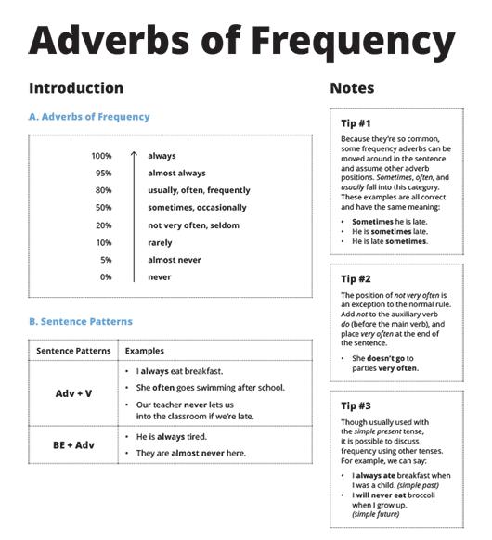
4
Discuss the pros (advantages) and cons (disadvantages) of 24/7 presence of social media in our lives. Write down your ideas in the columns below:

Advantages | Disadvantages

